Rebase

What is Rebase?
# Source: AI Source: Provided by: [Data Path: Persons Table -> ID Column: 1, Name_En Column: Motasem Essam] -> From: [ChatGPT] on [2/15/2026]
Rebase is a Git operation that moves or reapplies commits from one branch onto another branch, effectively changing the base of your branch.
It is often used to keep a clean, linear history instead of a branch with many merge commits.

Key idea
# Source: AI Source: Provided by: [Data Path: Persons Table -> ID Column: 1, Name_En Column: Motasem Essam] -> From: [ChatGPT] on [2/15/2026]
- Instead of merging two branches with a merge commit, rebase “replays” your commits on top of another branch.
- The commits themselves are copied as new commits, so history is rewritten.

Example
# Source: AI Source: Provided by: [Data Path: Persons Table -> ID Column: 1, Name_En Column: Motasem Essam] -> From: [ChatGPT] on [2/15/2026]
Branches
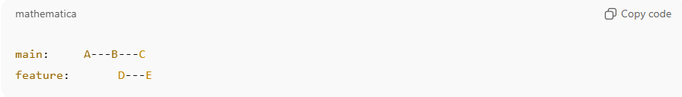
main: A---B---C
feature: D---E
If we rebase feature onto main:
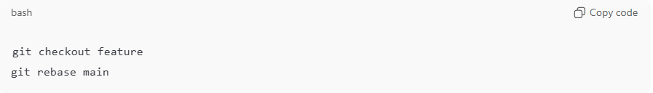
git checkout feature
git rebase main
Result:
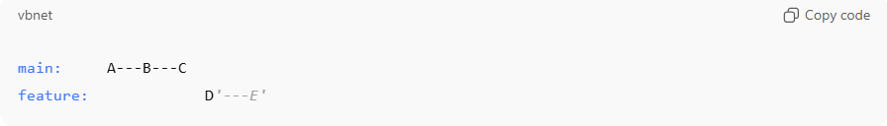
main: A---B---C
feature: D'---E'
- D and E become D' and E' — new commits applied on top of main
- History is linear, no merge commit needed

Commands
# Source: AI Source: Provided by: [Data Path: Persons Table -> ID Column: 1, Name_En Column: Motasem Essam] -> From: [ChatGPT] on [2/15/2026]
Rebase feature branch onto main
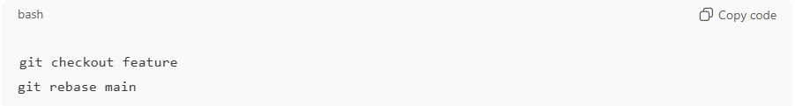
git checkout feature
git rebase main
Interactive rebase (edit/squash commits)
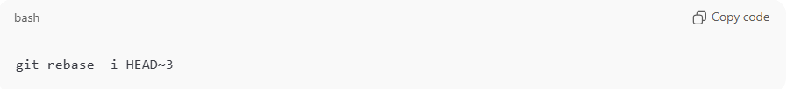
git rebase -i HEAD~3
- Allows you to reorder, squash, or edit commits

Rebase vs Merge
# Source: AI Source: Provided by: [Data Path: Persons Table -> ID Column: 1, Name_En Column: Motasem Essam] -> From: [ChatGPT] on [2/15/2026]
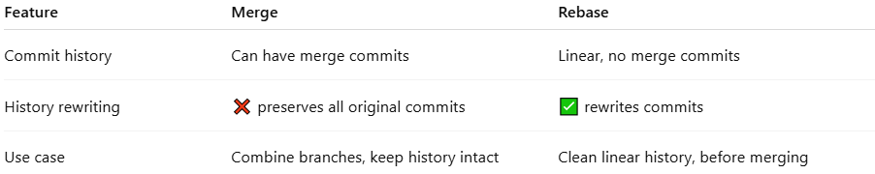
Feature | Merge | Rebase
Commit history | Can have merge commits | Linear, no merge commits
History rewriting | ❌ preserves all original commits | ✅ rewrites commits
Use case | Combine branches, keep history intact | Clean linear history, before merging

Important Notes
# Source: AI Source: Provided by: [Data Path: Persons Table -> ID Column: 1, Name_En Column: Motasem Essam] -> From: [ChatGPT] on [2/15/2026]
- Do not rebase public/shared branches → it rewrites history and can break others’ repos
- Safe for local feature branches that haven’t been pushed or shared
- Rewriting commits creates new commit hashes

💡 Memory trick:
# Source: AI Source: Provided by: [Data Path: Persons Table -> ID Column: 1, Name_En Column: Motasem Essam] -> From: [ChatGPT] on [2/15/2026]
Rebase = “move my commits to a new base” → linearize history ✅

